Mentor



Submission for Assignment 3
Introduction to Information Technology
at RMIT Online

Group #22

Jess Bayly s3766658
Chris Lai S3866221
Ian McElwaine S3863018
Charles Patterson s3865499
and Jayden Stewart S3863559

Website
https://a2-simple-b.github.io/A2_Group_22/

Group repository
https://github.com/a2-simple-b/A2_Group_22
Contents

Section 1 – Team Profile
1 | Introduction
2-4 | Personal Information and Team Profile
5 | Ideal Jobs
Section 2 – Tools
7 | Team comments on tools
Section 3 – Industry Data
9-11 | Industry Data
Section 4 – IT Work
13-15 | Interview an IT Professional
Section 5 – IT Technologies
17-19 | Autonomous Vehicles
20-22 | Cybersecurity
23-25 | Machine learning
26-27 | Robots
Section 6 – Project Idea
29 | Background
30 | Mentor
Section 7 – Group Reflection
32 | Group Reflection
33-35 | Individual Reflections

Section 1

Team Profile

A2 Group #22 – Team Simple </b>
Simple </b> is pleased to present this report as evidence of our work for Assignment 2 in Introduction to Technology at RMIT Online.

“Our team has people with a diverse range of skills and personality traits. We have found that having diversity in our team has balanced our organisation and provided a well-rounded working environment. We have enjoyed healthy discussions and clarity of purpose.

Each team member is a different part of the puzzle. By combining our skills together, we have been able to complete this project while physically located in different parts of Australia. With this idea in find, we combined the initials of our surnames (plus a couple of vowels) to form our team name” – SiMPLe </B>

Personal Information and Team Profile
Born and raised in Sydney, Australia. Jessica Bayly currently finds herself in Adelaide building a beautiful family. As IT has always played a big part of Jess’s upbringing, she is now perusing a degree in IT.
Jessica Bayly S3766658
In 1997, Jess discovered a whole new world when she got internet accessibility. She became familiar with mIRC and ICQ in order to communicate with other fans of Hanson.
Working in digital media, Jess decided to go down the path of IT and do what she loves. It is never too late to study and find herself a new passion and soon a new career.
As an introvert, Jess likes to observe a situation and is receptive to new ideas. However, as a natural defender, Jess will stand up for herself when in need.
Although she has a tendency to sit back and analyse situations, Jess is comfortable to present her thoughts and opinions during the meetings.
With new career path being planned out, Jess is ready to embrace a diverse team with a wide range of personalities. She believes that the best kind of group is to have people with opposite personality traits in order to have a balanced team.

Chris Lai S3866221
As a graduate, Chris Lai is intrigued to see that many finance positions value highly of people with experience in IT. Chris believes that the financial sector is ever more intertwined with technology and to learn the basic of IT will soon be a requirement rather than a bonus point on the resume.

With no prior experience or academic training in the IT field, Chris believes that understanding the fundamentals of the IT Industry will benefit him throughout his career.

As a protagonist person (ENFJ-A) who is passionate at things he does and unafraid to speak up when something needs to be said, Chris will be an excellent value-add to the team working closely with the team while building good relationship among team members.

Chris is a visual learner who is best informed with visualised diagrams and notes. As a huge fan of breadcrumb trails, he will appreciate a clear timeline to follow the workflow and deadlines.

Although Chris is forced to change the trajectory of his career path earlier this year, he had since discovered that positions with relationship management and sales would be ideal for him and by being able to pitch ideas, he will be beneficial to the team in future projects.

Based in Albury, Ian McElwaine developed a keen interest in IT since young. As an expert IT user and a full-time musician, Ian applies a variety of applications and instruments to record music, perform live and teach.
Ian McElwaine s3863018
Lenny, an inspirational person, introduced Ian to sound synthesises, MIDI sequencing and other industrial electronics that sparked Ian’s interest in IT.
With an inquisitive mind, Ian learned about the fundamentals of how a modern PC operates. His experience in using command line and principles of Linux & GNU helped him set up a personalised home IT system.
As an Assertive Protagonist, Ian is an expert in being a diplomat and a coordinator. He believes that a good coordinator works for the group and facilitate the implementation process of decisions made by the group.
With years in the field of music, Ian scores very high in auditory being his preferred learning style. Nevertheless, Ian believes writing can help absorb information better and will appreciate consistent verbal communications with the team members.
Scored 125 on his IQ test, Ian reaffirmed that success is a result of discipline, determination, hard work and perseverance. As a team member, Ian will be a reliable player and contribute stable output to the success of the team.

As a Sydneysider, Charles Patterson enjoys working on cars and the uncapped potentials of IT systems. While having a busy lifestyle, Charlies aims to develop further knowledge that can land him a career in IT.
Charles Patterson S3865499
While designing custom Minecraft servers and troubleshooting in primary school, Charles discovered a wide range of possibilities with the IT machines.
As time progress, Charles excelled in python programming, web design and video production that He realised a career in software design will be an ideal choice.
With very stable personality traits that make him compatible to work with a variety of team members, Charles value the opportunities for alternative voices in a team to enhance creativity and productivity.
As a well-rounded person, Charles’ learning style is no exception. He focuses evenly more on visual and tactile and much less with auditory (20%). As a great example, he is more prone to drawing diagrams as a way to present information, which is highly compatible with the group.
Thinking in abstract and sophisticated ways while having the self-discipline to pursue his goals, Charles will be an excellent team member in putting others first. At the same time, provide remarkable progress for group projects.
From Brisbane, Jayden Stewart always has the drive to create his own technology company. While he was working full time and had exposure in business, he is aiming to learn and explore some aspects of IT he hasn’t heard of.
Jayden Stewart S3863559
Elon Musk, as an innovative leader, hoping to enhance the livelihood for future generations, has relit the fire for Jayden to pursue the path of IT and improve sustainable future for humanity.
With a decent knowledge of C++, Linux and a fair bit of experience in machine learning, He is hoping to progress through the course and built a solid foundation for his career goal and to create his projects.
Jayden is an extrovert with a tendency to be more blunt and forthcoming with their emotions. In a group work setting, Jayden can be more spontaneous and deemed as relaxed in comparison to other team members. Jayden’s personality traits will fit into the group relatively well and contribute his strong knowledge in programming for group projects.
As a person who is experienced not only in the field of IT but also business, Jayden is happy to deploy different tools for his learning journey and enjoy different formats to study.
Aligned with his career goal, Jayden has a high level of curiosity and complexity in his creativity. It will work in the team’s benefits to provide ideas and to facilitate the brainstorming process of group works.

Ideal Jobs
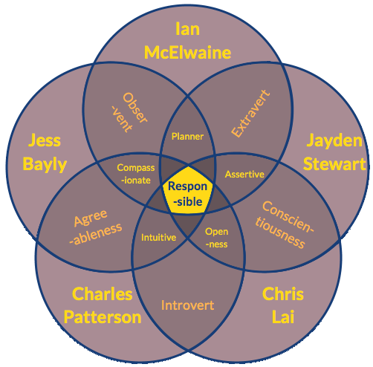
The members of Simple </b> have a clear sense of purpose in their study and career choices. We have already thought about how our education pathways will lead to employment in our chosen fields. Our choice of ideal jobs has not changed from Assignment 1.
There is some overlap among the team:
- Jess, Ian, and Charles are interested in careers in the Network administration field.
- Chris is still interested in Sales and Marketing
- Jayden is still interested in Software Development, with a special interest in low level languages like C and C++

Section 2

Tools
Tools
Our team website is at: https://a2-simple-b.github.io/A2_Group_22/
Our team Github repository is at: https://github.com/a2-simple-b/A2_Group_22

Our team chose to use these tools:
- Github
- Plain text files for individual writing tasks
- Google Docs for joint writing tasks
- Google Meet for team meetings
- A team intranet site
- A Slack Workspace

Due to time constraints, our team did not develop a Github workflow that met the needs of each member. The GitHub log of activity accurately reflects our fairly inefficient workflow at the beginning. Ian was doing web development and had got into the habit of committing directly to the master: /docs directory. If errors were made then this would result in the rollback of the master branch causing other brands in the organisation to also pull these rollbacks. Despite this, we can see how useful it was for Ian to conduct his workflow on the master branch, as GitHub Pages interacts differently with extensions compared to local versions of websites.
Charles also developed the habit of constantly pushing updates to the master repository, A better way of doing this would be updating in versions once tasks are fully completed. We later discussed this and tried our best to remove these mistakes. We hope to have our workflow refined for Assignment 3 and Assignment 5.
Image by Nam Nguyen from Pixabay
Although the team agreed to use Google Docs for group writing tasks, none of the team member members used this tool.
Slack proved to be a useful way for team members to communicate, and was our typical method of communication. We used Google Meet for team meetings which proved to be a friction-less experience.

Section 3

Industry Data
Industry Data

For our group, the three ideal jobs that most of our group mates resonate with are systems engineer, systems administrator and software developer. According to the data supplied by Burning Glass Technologies, the three ideal jobs were in the 98.5, 96.5 and 91 percentiles of the IT jobs in March 2018. According to the Australian Government – Job Outlook website, both the Software & Applications Programmers and Systems Administrators categories indicate a robust future growth with great weekly pay.¹ These statistics can prove that the ideal jobs we are aiming for in the IT industry provide a stable career path with high demands in the present and future labour markets. Chris is interested in a career in Sales or Marketing, so data for his chosen career is not available in this dataset.

According to the required IT-specific skills for our ideal jobs, Java, Microsoft Windows, Linux and C++ ranked the highest in terms of demand from the employers. It can be interpreted that the ability to write different computing languages and experience in using different operating systems will make you a highly competitive professional. Other required skill sets that are not quite in demand are the experience in VPN, Hyper-V and VMware ESXi.

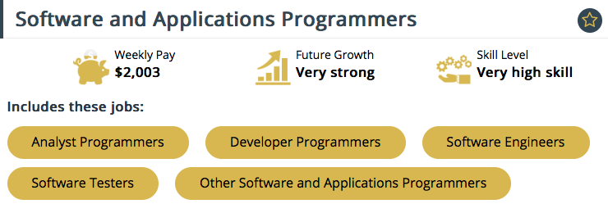
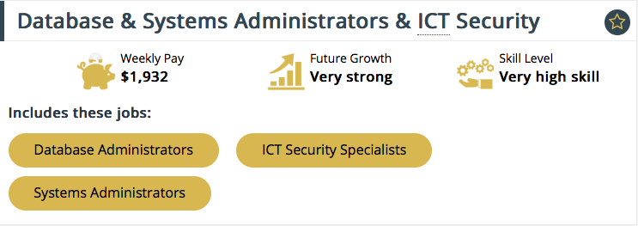

The highest-ranking IT-specific skills that are not in our necessary expertise are SAP, Oracle and Git. For a visual interpretation of the competitiveness of required skill sets, please refer to the diagram below for the ranking and respective percentiles.
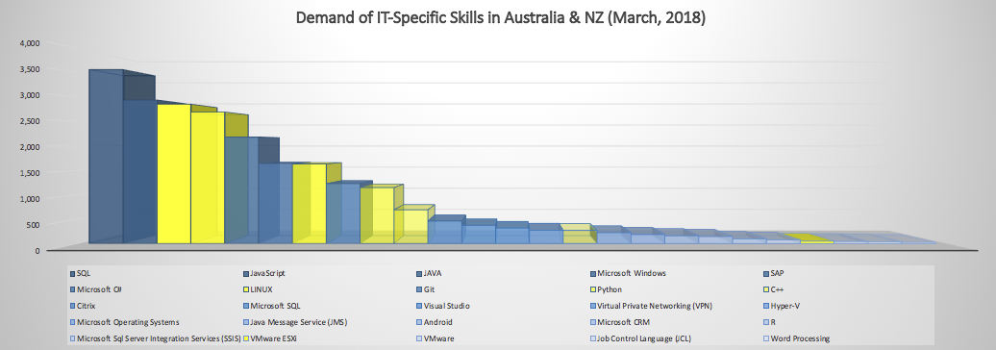
Apart from the required IT-specific skill sets for the ideal jobs, some general soft skills are equally important. For our ideal jobs, having the ability to solve clients’ issues and last-minute obstacles through investigation and critical-analyse is crucial. Those three skills ranked at the 96, 92.5 and 78 percentiles and can be deemed as high demand from employers for the foreseeable future.
While communication, writing and organisational skills are the highest demands of general skills that a potential employer wants, those are not the particular skills that are required for our job requirements.
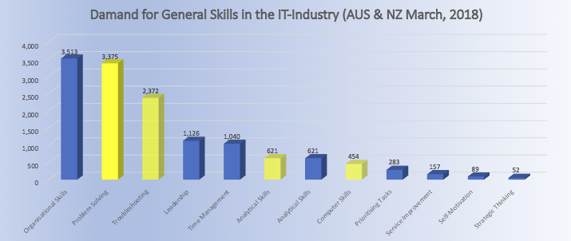
After investigating the available data, our opinion in what career paths we wish to pursue had not changed. The team members who will seek to be a developer or administration position have knowledge in coding and exposure with different operating systems. Once they went through the degree with RMIT, the necessary technical skill sets in high demand will be acquired.
From working through the assignment together, it is proven that the teammates have soft critical skills such as problem-solving and analytical skills. As the expertise is perfectly aligned with the future demands for IT-related positions, we believe that the ideal jobs provide a stable career path for future growth.
While the demand for usual jobs like software developers and systems engineers are on the rise, an avalanche of new technologies and surging globalisation are reshaping the future needs in the IT industry. As Amanda Mclntyre – Consulting Partner, PwC Australia pointed out, creativity, cognitive flexibility and negotiation skills are going to be highly desirable to meet the ever-changing market. It is vital to not only looking at past data to be job-ready but also analyse what new jobs will emerge and subsequently, will we still be competitive in 5 to 10 years.²

References
- 10 Skills You Need For Future Employment, PwC Australia. https://www.pwc.com.au/careers/blog/future-employment.html. Retrieved on the 17th of July 2020.
- JobOutlook, Australian Government. https://joboutlook.gov.au/Default. Retrieved on the 16th of July 2020.

Section 4

IT Work

Interview an IT Professional

Jess Bayly, Interviewer, Simple B
Rene Cocks, Senior Systems Engineer at Subnet
Monday, 6 July 2020
(The original audio file is hosted on our team website)
Jess | Hello Rene
Rene | Hello
Jess | First of all, thanks for taking some time out of your busy schedule to have a chat with me, I really appreciate it. I hope you don’t mind that I am recording this and if you want a copy, I can pass it along if you need it for anything.
Rene | Nope, That’s OK
Jess | All right, well I’ll get straight to it. So you’re a Senior Systems Engineer at Subnet?
Rene | Correct
Jess | What exactly does your day to day work involve?
Rene | It kind of changes on a day to day role, a day to day basis sorry. .. like we do here… helping with design solutions, costing solutions and yeah, just general support and implementing solutions as well.
Jess | Right….. and the type of clients that you typically work with for solutions, what fields are they in?
Rene | Yeah, a bit of everything. We touch a few not for profits. Trying to think of who else.
Jess | You guys do Education, like the schools as well don’t you?
Rene | Yeah, that’s kind of dropping off though. Pulling it all into them self, to try and push any third party providers away but personally myself, I’m kind of accounting and not for profit… mostly around Citrix solutions.
Jess | What is Citrix?
Rene | Okay… So that is a solution that allows you to work from home… It’s come in quite handy over the last few months
Jess | Right, so due to COVID you have a lot of interest in Citrix at the moment.
Rene | Well I wouldn’t put it like that because of the time setting it up for people, but for the people that already got it, have really managed to take advantage of it.
Jess | Ok gotcha. What other kinds of work are you required to do at Subnet that isn’t really typical of a Systems Engineer job?
Rene | Look after the front desk.
Jess | Yep, oh so help desk stuff
Rene | Well, even Reception.
Jess | Oh right
Rene | I’ll sit in reception if reception’s not there.
Jess | So if clients come in you might be sitting at the front greeting them?
Rene | I’ll go and look after them if reception is not there, apart from that though that’s probably the only case.
Jess | Right, so you obviously have a lot of client relationship experience
Rene | Correct!
Jess | To get to where you were, did you study many years, did you study a degree?
Rene | Yes, I’ve got a Bachelor of Computer Science
Jess | Computer Science, Ok, and was that your goal, to become a Systems Engineer?
Rene | Probably not at the time. So Computer Science degree is more focused on programming and that kinda stuff. I was kinda a bit burnt out when I finished Uni I kinda just fell into this path to be a Systems Engineer
Jess | What aspects of your work do you find you spend the most time on every day
Rene | Um it can change from day to day. A lot of it is UAT and testing
Jess | You find you do that on a daily basis, something routinely.
Rene | Well it depends, I'm kind of knee deep in project stuff at the moment. I’m kind of just trying to finish off a server refresh for council. All of it has gone really, really easy, until the last bit which is the end user interface bit and that's taking up, taking multiple months because it requires testing and users don’t.
Jess | You test for months on end, or do you get people to test, how does that work?
Rene | We get users to test, cause we don’t know how the applications work our self in terms of the finance package or…
Jess | Where do you find users to do that?
Rene | Clients get volunteers – we get volunteers via our contacts
Jess | Do you find any aspects of your work quite challenging?
Rene | Probably just keeping up with workload.
Jess | Keeping up with workload, so it’s just constant busy time.
Rene | Yeah, um cause I’ve got a pretty good relationship with so many clients
Jess | It’s hard to give them all… the same?
Rene | Yeah, same level of service every time.
Jess | Do you like the challenge that comes with your job?
Rene | Yeah yeah for sure. One day we’ll retire and be a IT Manager but we can’t do it now because we’d get too bored.
Jess | Are there any other areas of the IT Industry that you’d like to work on or possibly move into?
Rene | Yeah down the road, when you retire – something less stressful.
Jess | Less stressful, so an IT Manager do you think will be less stressful?
Rene | Depending on what level it is.
Jess | Do you think you’ll be a Systems Engineer for a while yet? Can you see yourself changing paths?
Rene | Probably not in the next couple of years but maybe after that yes
Jess | Do you get to work with new technology? I wanted to ask you when you speak with clients, do you sometimes always have to sell what you work on. For example they might need to upgrade to office 365 but they might have a CFO that doesn’t agree with that, do you find that challenging? Having to know that you’ve already upgraded and you’re working with clients that are advanced and then you go back to other client who is still in the dinosaur ages?
Rene | I wouldn’t say dinosaur age but yes, can be challenging yes.
Jess | So your normal 48 hour work week, is that normal for you? or are you on call after hours when things go badly?
Rene | Yeah, so I'm on call 24/7,
Jess | So that's part of your contract with Subnet?
Rene | Yes, well its extra on top of what we already do. We do get compensated for it... quite generously.
Jess | With technologies constantly changing, is there any technologies that you haven't worked with yet? or want to work with given the chance?
Rene | All the time, its a matter of only being able to take on so
Jess | Like AI or Robots?
Rene | I'm thinking more from a product perspective. I think AI and Robots and that kind of stuff is still getting there... Still in the future.
Jess | So what kind of programs would you be interested in at the moment but haven't explored yet.
Rene | I would like to do a lot more Azure, which is basically Microsoft's public facing crowd offering.
Jess | Are you a MAC or a PC guy?
Rene | PC
Jess | Well I think I might leave you with that. Thank you so much.
Rene | That's alright.

Section 5
IT Technologies

An ”Autonomous Vehicle” can be any vehicle that is capable of sensing its own environment and drive without human operation. There is a difference between automated and autonomous vehicles: Automated vehicles take instructions and will not go beyond that, whereas an autonomous vehicle can fully think for itself so if it decides to drive somewhere without human instructions it can.
Photo by Mitch Nielsen on Unsplash
There are currently many reasons why autonomous vehicles haven’t been released to the public as of yet however they are still being developed and tested to ensure the best results. Companies such as Alphabet (Google’s parent company), Tesla, BMW, Audi, Amazon, Uber and plenty more are all working towards a future for autonomous vehicles. These vehicles have many different detection mechanisms to assist the car becoming aware of its surroundings.
The current methods of the vehicle awareness is using Radar and or Lidar as some companies progress choosing one or both of these mechanisms in the combination with artificial intelligence and driving experience. These vehicles gain experience by driving in the real world and in a simulated reality over millions of miles making them more experienced than humans however they still had to learn to drive which could have taken a long time especially if they didn’t have the option to create a simulated reality for their vehicles.
Developing autonomous vehicles can be quite challenging due to many implications such as the type of awareness the vehicle manufacturer is going to implement since Lidar is an expensive option and can interfere with other autonomous vehicles on the road while radio frequencies can be a better alternative if there is enough frequency range to communicate with all the vehicles which is why 5G radio frequencies will be a very good advancement towards the future to support technology advancements that may have been restricted. The type of weather can also have an impact on the use of autonomous vehicles if they are unable to detect the road and drive to limiting awareness conditions, for example if the road was covered in snow there may be no way the vehicle to continue driving since it doesn’t know where the road is. Road regulations in Australia will be quiet strict on the future vehicles as they are only preparing to automated vehicles and no mention of autonomous vehicles unlike the United States who have been welcoming the future advancements while staying political about the matter. Another hurdle autonomous vehicles need to leap over is artificial intelligence vs emotional intelligence in being able to make decisions based on instinctive behaviour that technology cannot comprehend currently to a capable extent.
Benefits of autonomous vehicles are beyond current circumstances with the manually operated vehicles used by society today. During the first major COVID-19 outbreak, everyone had the chance to notice pollution levels had lowered especially in Hong Kong due to planes not flying and other transportation methods reduced. A prediction made with the rise of autonomous vehicles all being electric will be an outstanding 80% reduction in urban CO2 emissions on a global scale which will positively impact the earth and its beings.
The current stage of autonomous vehicles is not anywhere near the prediction that was made five years ago however there have been a lot of advancements towards the technology that will contribute in making vehicle autonomy a reality. Further development is necessary to provide a vehicle that is safe enough to be on the road and have passengers, smart enough for decision making and intelligent to perform tasks that require critical thinking. A lot of these advancements may contribute to other technology advancements in the future such as better performing artificial intelligence, Sci-Fi like transportation as seen in movies and overall being more ecofriendly.
Automated vehicles could be another ten years away with the current progression made in the field however this is just an assumption and autonomy vehicles could be a further ten years away so around the year 2040 as artificial intelligence should be much more advance, giving time now for computer scientist, engineers and other fields to develop the technology in a popular and growing industry that will revolutionise the world and will keep on continuing until civilisation reaches a plateau. Overall the technology advancements will take a fair amount of time but it is good to know companies have already been working towards vehicle autonomy for near two decades now so they should be close to reaching a breakthrough that will give them the answers they need to release the vehicles publicly as most of the time the vehicles are on private property continually being tested.
Photo by Roberto Nickson on Unsplash
Autonomous cars are the main goal for industry leading companies in the motor and computer sectors and once they have been achieved to a satisfactory level the next step is to engineer trucks, motorbikes, boats, helicopters and other transportation. Conventional cars today will be the old and electric cars will be the new with the main benefits being they are faster, cheaper and more durable than any car before. Vehicle safety will increase by a large number with the car having automated safety features that will be able to calculate what to do next. Traffic congestion levels will decrease while freeing up parking lots since to call your car to pick you up will only require download the cars manufactures app.
People who can afford these vehicles will definitely choose them over the motorised vehicles of today with the cars being so advanced and all it’s features being very futuristic and more convenient for the owner. Companies that pay truck drivers will choose autonomy in the future with the potential to save money and delivery will be faster with the driver not needing to have any lunch break or a sleep overnight. The advantages of autonomous vehicles will carry over to plenty of industries leading the way and encouraging the robotics field to replace many working roles.
Electric cars are the future for society and to encourage usage they will be affordable and competitive allowing the majority of people being able to purchase them however the autonomous vehicles may be slightly more expensive with it having more features than a standard electric and automated vehicle. Traffic congestion will happen less frequently meaning more people will be on time for work as the cars will be able to calculate travel time and less people will be driving slow as cars will know the speed limits and will adjust accordingly. If someone doesn’t own a car than they can order Uber Autonomy and be chauffeured to their destination.
More people will be living a luxurious lifestyle with better built cars and can be doing their work or study while travelling which will increase productivity for the majority of society.

References
https://www.synopsys.com/automotive/what-is-autonomous-car.html
https://www.cbinsights.com/research/autonomous-driverless-vehicles-corporations-list/
https://www.mes-insights.com/5-top-autonomous-vehicle-companies-to-watch-in-2020-a-910825/
https://www.infrastructure.gov.au/transport/automatedvehicles/index.aspx
https://www.nature.com/articles/s41558-020-0797-x
https://www.hindawi.com/journals/jat/2018/6135183/
https://www.mercedes-benz.com.au/passengercars/experience/mercedes-me-magazine/performance/articles/how-autonomous-driving-could-change-lives/story-content.module.html
https://www.forbes.com/sites/uhenergy/2019/05/21/self-driving-automobiles-how-soon-and-how-much/#e2a771438bd2
Due to technology expanding rapidly, ”Cybersecurity” is a growing field that will continue to grow until such time. New devices are being created and will be connected to the internet using 5G. Most devices will be vulnerable to attacks and that’s why machine learning is also growing in the Cybersecurity field in hopes to minimise vulnerabilities in technology.
The most common attack vectors in Cybersecurity are already regulated with machine learning, specifically when it comes to financial assets. Hackers will continue to target health and financial organisations due to their high value and worth. These organisation sectors will always work to be the most secure and will implement strategies to prevent attacks and protect its customers.
Photo by Chris Ried on Unsplash
The rise of ransomware has costed organisations billions of dollars every single year and machine learning may not be able to prevent every attack vector. Quantum computers are designed to calculate complex algorithms that non traditional computers can’t. Quantum computers will be able to break cryptography and weaken ones that can’t be broken. This may be possible within the next three years but only to people and organisations who can afford a quantum computer due to how expensive the system costs and to maintain it.
Security experts continuously look for vulnerabilities in both software and hardware to report the flaw to organisations. Usually these organisations offer a bug bounty program which offers money or reputation in return for reporting the vulnerability. Because of this, the Cybersecurity industry will become increasingly more competitive and more people are coming to the field due to the high demand.
In the next few years, Cybersecurity will have evolved becoming entirely different from the current circumstances due to technology evolving but the principals and methodology will have stayed the same. Security will have changed massively as companies increasingly make employees more aware of social engineering attack vectors which is one of the most effective ways at attacking targets as people can be more vulnerable than the machines they use and once an attacker gains access it can be difficult to claim back the device and costing millions of dollars.
Cyber security will continue to be a rising industry due to the necessary protection of peoples and companies private information such as account numbers, passwords, security questions, bank reports, etc. Criminals like to steal information to use for fraud and or other personal gains as they can be very valuable. Say you have an account on a website and you pay for a yearly subscription worth over $100, a cyber-criminal will find it very beneficial to steal those accounts from people and sell them for lower prices as the criminal isn’t paying for it and can keep all the profits from your money. This is why many cyber security companies have created many different protection methods to keeping your data secure with a fee.
Virtual private networks (VPNs) are a great way to encrypt all your internet traffic when connect to hotspots more particularly at hotels, airports and cafes. Hackers are able to redirect all your traffic through their computer with the ease of just running a public program on their side. VPN companies make incredible profits for their security services they provide to customers and are able to advertise their other services which is very laser targeted because individuals and organisations who are already concerned about cyber security are very likely to take advantage of other offers that will increase their protection. The only fault with virtual private networks are the fact you have to trust the organisation that they don’t keep logs if you really want to keep anonymity however some companies will tell you they do which shows their honesty.
Passwords are the key to private information such as bank logins, VPNs, PayPal, emails, YouTube and every other website with an account feature. A service that is very popular for customers who use a virtual private network is an account manager that will store all your logins including emails, usernames and passwords. These accounts are usually stored in the cloud so a user can just log in on any of their devices to use any of their stored credentials and this allows the customer to have complicated passwords that are not so easy to remember. The benefit of having a password manager is only having to remember one login which acts as the master key to other keys and this data is usually always encrypted to prevent cyber criminals from viewing your passwords even if the website was hacked.
Encryption is used to keep data secure when people may have access to the data leaving the intruder unable to read it. Websites usually encrypted your login details and their logs to prevent hackers from viewing information even if they have gained access to the website. All encryption uses complicated mathematical algorithms to make data harder to decrypt unless the attacker had access to the key or a quantum computer. As mentioned before, quantum computers will be a downfall for encryption making it not so much a viable solution however there may be hope with quantum safe encryption replacing standard encryption.
Doxing isn’t so much hacking and is more private investigation upon mostly individuals when people are searching for information such as date of birth, address, phone number, usernames, locations and so much more from the comfort behind a computer so no work has to be completed following people around. These little pieces of information can lead to fraud, password cracking and other attack vectors, one of them being a sim swap attack.
There are lots of different attack vectors that could be used to exploit many situations and gaining access to user data. Sim swap attacks have started being utilised recently and involves social engineering to complete the attack. Firstly, social engineering is the process of manipulating people into doing tasks with the attack imposing as someone they are not. Lets say someone has doxed (the completed process of doxing) an individual and they find out the person has a lot of money stored in bitcoin. The attacker already knows the internet service provider the victim users due to knowing the phone number and from there are able to retrieve that information online. The attacker calls the company from the victims phone number using a process known as spoofing and imposes as the victim and says they need to do a sim transfer to one they have in their possession. This will allow the attacker to bypass to security function known as 2-factor authentication which relies on the user logging in with their normal details but have a code sent to their phone however there is other ways for the user to protect themselves.
All in all Cybersecurity with be advancing in the future as new attacks rise so will the protections otherwise the internet would not be very safe. Outdated attacks get repurposed in some situations and others they are obsolete never to be used again however the knowledge of how they work can come in handy to prevent the same mistake. Cyber security is a serious area of technology that needs to be always advancing and knowing what the latest trends attackers are using.

References
https://www.disruptordaily.com/future-of-cybersecurity/
https://www.greenlight-itc.com/cyber-crime-security-statistics-australia/
https://www.okta.com/blog/2019/07/the-impact-of-quantum-computing-on-cybersecurity/
https://www.dst.defence.gov.au/sites/default/files/publications/documents/Future-Cyber-Security-Landscape.pdf

”Machine learning” is a program that has been instructed to learn using mathematical equations. There are different types of machine learning such as unsupervised learning, supervised learning, semi supervised learning, reinforcement learning. Each type of machine learning technique uses a different or a combination of algorithms. Machine learning is actually a subset of artificial intelligence and without the mechanic of machine learning, creating an artificial intelligence becomes increasingly more difficult.
As machine learning is a subset of AI; deep learning is a subset of machine learning. Deep learning is the process of a bunch of nodes (also known as neurons) that take input and output. Each node has weights that when processing data, the neurons can have influence the outputs. This being said, a lot of machine learning has to be configured after trial and error.
Programs that make decisions based on machine learning continually evolve and become superior than traditional programs that have been coded to complete tasks statically. Since machine learning has made a lot of progress over the decades, it has been implemented into the daily lives of billions without the realisation or understanding from its users.
Big companies now use machine learning in order to evolve and be at the top of their game. YouTube for example uses machine learning to read videos both audio and visuals and compares the content uploaded to match suitable videos for its users. This is extremely effective when providing the user suitable content that they will much more likely be interested in and watch it for longer than other videos. Previously YouTube would’ve used video titles and video ratings alone when making recommendations which is not as effective.
Facebook uses machine learning. Since Instagram is owned by Facebook, they share some functionalities. Facebook has the ability to read your photos and understand who and or what is in the photos which is helpful when tagging people, the text you post can be meaningfully understood using a deep learning engine called DeepText. The advertisements displayed on Facebook and Instagram are laser targeted using machine learning when prior the advertisers had to manually select who they want to target but now Facebook know if you like to shop, follow accounts and web-pages, if you like funny videos and so much more.
Photo by Pietro Jeng on Unsplash
The data used Facebook uses isn’t just from Facebook themselves, it is provided from other data collection companies as well to accurately profile you with their deep learning engine which shows how powerful data can be when combined with machine learning. Facebook can also translate languages well without errors using machine learning, unlike other popular automated translation services a decade ago.
Machine learning is capable of much more than just interacting with the cyber world. NASA has held a competition that involved machine learning to design and construct a strong, efficient and safe home made out of dirt from Mars. Tesla has fully self-driving cars that uses machine learning, and there are many other scenarios where machine learning can be implemented. It is now realistic to do nearly anything with machine learning, in particular subjects it can become smarter than humans in a short period of time due to hardware like graphic cards that are built specifically with artificial intelligence in mind.
The next few years will hold amazing changes to society through the use of machine learning. Since the COVID-19 outbreak there have been labs using machine learning to predict outbreaks and finding a cure. Agriculture is also another field being changed by machine learning with a more efficient and effective way of growing food. It isn’t too far-fetched to say homes will be power by machine learning very soon, assisting the occupants with tasks such as turning a television on when it predicts you’re going to watching television or knows when you are to be woken up and going to sleep.
Machine learning will change the world unlike anyone would think because it’s not people that will be thinking as much as machines will be. Machines will power advancements to society and humans will most likely just be designing and maintaining the machines until that is no longer needed. Humans will quickly advance the Kardashev scale by having machines do a lot of problem solving it takes to reach the next level. Jobs will quickly be replaced by computers and there will be new jobs generated.
How will this affect you? A lot of people are worried that machines will take over everyone’s job, making people fat and lazy when this isn’t true as there will be jobs for a very long time however maybe they are easily replaceable by a machine. If people are worried about being replaced by machines because their job is so simple that at the stage of civilisations technology currently is, than they should be working to equip themselves with more skills and adding value to their lives. It is inevitable that machines will advance and if people aren’t willing to advance themselves than they shouldn’t be complaining as the entire idea of machine learning is to assist people and creating a better world whatever the small changes may be.
The education system should advance with the help of artificial intelligence so schools will be able to teach more effectively that way children can grow to be more smart and intelligent, contributing to society in a much more helpful way. Shopping can become a lot easier with a computer ordering all the necessities and delivering the product to the door, this can save a lot of time and energy not needed to be wasted while the person is working or spending time with their family. Vehicles will be completely autonomous with the help of machine learning playing a big part. Everyone being a passenger in the car can be a much safer option especially if people are unable to drive.

References
https://www.geeksforgeeks.org/5-mind-blowing-ways-facebook-uses-machine-learning/
https://engineering.fb.com/core-data/introducing-deeptext-facebook-s-text-understanding-engine/
https://www.facebook.com/business/news/good-questions-real-answers-how-does-facebook-use-machine-learning-to-deliver-ads
http://www.whatafuture.com/machine-learning-algorithm-for-youtube-search-results/#:~:text=YouTube%2C%20as%20per%20the%20patent,to%20this%20machine%20learning%20model.&text=This%20will%20let%20YouTube%20recognize,than%20just%20the%20textual%20data.
https://www.forbes.com/sites/bernardmarr/2019/08/23/the-amazing-ways-youtube-uses-artificial-intelligence-and-machine-learning/#49472c6d5852
https://www.cambridge.org/core/journals/infection-control-and-hospital-epidemiology/article/identification-of-covid19-can-be-quicker-through-artificial-intelligence-framework-using-a-mobile-phonebased-survey-when-cities-and-towns-are-under-quarantine/7151059680918EF9B8CDBCC4EF19C292/core-reader
https://journals.physiology.org/doi/full/10.1152/physiolgenomics.00029.2020
https://covid19-projections.com/
https://thenextweb.com/insights/2020/03/04/scientists-need-your-computing-power-to-find-a-cure-for-coronavirus/
https://foldingathome.org/start-folding/
https://medium.com/sciforce/machine-learning-in-agriculture-applications-and-techniques-6ab501f4d1b5#:~:text=Mostly%2C%20machine%20learning%20techniques%20are,Support%20Vector%20Machines%20(SVMs).
https://towardsdatascience.com/7-reasons-why-machine-learning-is-a-game-changer-for-agriculture-1753dc56e310
https://theurbandeveloper.com/articles/the-future-of-smart-homes
https://futurism.com/the-kardashev-scale-type-i-ii-iii-iv-v-civilization

A “Robot” is a machine designed to execute tasks in an automated fashion to reduce the need of human intervention. The industrial sector uses robotics for the majority of manufacturing tasks such as lifting and welding parts together using what the robot has been gifted. Many people think of robots as machines designed to appearance human with the functionality of completing daily tasks however that is just a single type of robot with a human model and the name for this type of robot is an android. The android robots aren’t actually capable of being thinking, learning and apply learned knowledge without an artificial intelligence program being loaded however a full AI program is unlikely to loaded into a machine with real world capabilities for a long time until AI is more understood and we aren’t even at such as stage yet so machine learning would be the second option.
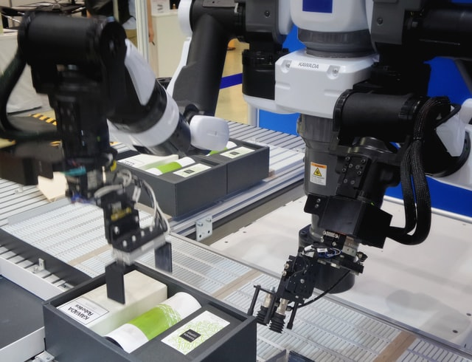Photo by Franck V. on Unsplash
Robots are used in the military all the time as it saves human lives from people who are potential threats. Military robots can either be autonomous or remote controlled mobile robots however either method of controls will still do it’s job and can be more easily replaced than someone who is in control of the robot. These military robots have many capabilities and uses such as detecting and disabling bombs, flying over the enemy bases and dropping bombs or detecting locations of enemy forces, transportation machines with weapons attached and automated firing and so much more.
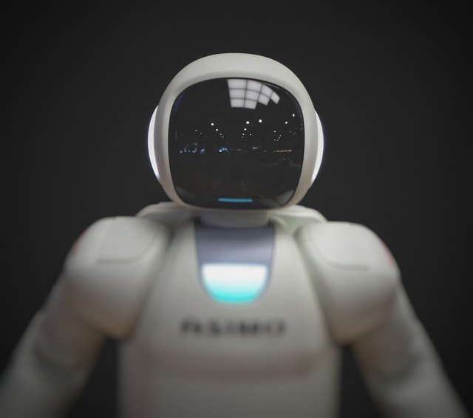Photo by Franck V. on Unsplash
Boston Dynamics is a company widely known for the engineering of multipurpose robots and has even received funding from the Defence Advanced Research Projects Agency (DARPA) for many years and have not disclose the reason why however the reasoning may already be obvious. Boston Dynamics have recently released their robot dog also known as SPOT, however this robot model does not look too much like a dog and does not act like one either besides the part of doing it what you tell it to do. SPOT is a robot designed and sold to big companies for many different uses and has the capabilities of fully functioning autonomous which is a very big leap to the future. This robot has the ability to work in construction, mining, healthcare, public safety, oil and gas, research and as entertainment with the optional feature of sensors, an artificial learning device, and other types of add-on awareness.
Robots will likely be doing most of humanity’s menial work eventually. Automation is the future of work, so people should prepare for future careers by studying at least some STEM subjects in school. Studying engineering and learning different skills should keep a person relevant and hire-able instead of redundant. People however could be lazy and unmotivated without the need to do simple and boring tasks such as cleaning the dishes because we have dish washers and maybe a robot that will even rinse the dishes before hand the clean the dish washer after or wash the clothes and hang them to dry.
With the advancement of robotics, many different industry sectors will evolve to complete tasks way better on every dimension than a human being. This being said there is still a long way from this for example, can we really trust a machine to operate on a human being and complete the task more effective and safely. The difficulty of these situations are because we haven’t had much research and advancements into these scenarios because like I stated above, who would really participate in being the subject for any trial people are running.
Having more robots advancing society is very appealing to myself as it could potentially make my life a lot more productive and easier. It saves a lot of time knowing I have a robot to clean my floors instead of spending thirty minutes doing it myself when I could easily find a better thing to do such as spending time with my family, going to the gym, studying, working and the list goes on.

References
https://searchenterpriseai.techtarget.com/definition/robot
https://www.quora.com/How-are-robots-made
https://www.valin.com/resources/articles/five-types-of-industrial-robots-and-how-to-choose-the-best-fit
https://en.wikipedia.org/wiki/Boston_Dynamics

Section 6

Project Idea
Background
This is a summary of the team’s Assignment 1 project ideas.

- Jess Bayly explored a project which would apply machine learning and social media scraping to create a friction-less user experience when applying to enrol in university and vocational courses.
- Chris Lai was concerned about missing flights, and thus conceived a location-aware just-in-time push messaging service.
- Ian McElwaine wanted to get affordable music production equipment into the hands of young music producers. This incorporated a music publishing platform with simplified licence terms for remixing.
- Charles Patterson was interested in solutions for shopping precincts that incorporated location awareness and push notifications.
- Jayden Stewart is interested in machine learning and wanted to work on improvements to virtual personal assistants like Siri, Alexa, or Google Assistant.

Team Simple </b> discussed these project ideas and condensed them into a single project:
As students at RMIT Online, we have been using a Virtual Learning Environment (VLE) called Canvas. We have examined the popular platforms in the VLE space. and our team believes that there is an opportunity to disrupt the status quo, improve student experience, and deliver better educational outcomes.

Mentor
We propose to integrate machine learning, in the form of bots, into a fork of the Moodle project to create Mentor.
Mentor
We have a wish list of features for Mentor, but we are planning to implement a simple feature set at launch.
Our full wish list of features is:
- Support existing Moodle features and most extensions.
- An interactive chat bot that can discuss the users interests and help them choose an education pathway.
- Reduce the need for human tutors by training bots in pedagogical practise and supporting learners who need that extra bit of assistance to succeed.
- To support cohort and non-cohort based education strategies.

We have heard some anecdotal evidence which suggests that some students feel intimidated by lecturers and tutors. They have remarked that they would feel more comfortable interacting with a bot instead of a human tutor. According to data from Glass Door, university tutors earn around AUD$47 p/h, so there is an opportunity for education providers to reduce overheads by using well trained chat bots to interact with students.

Hi there,
how can I help?
Learn physics

We hope to do some development on the Moodle fork during Assignment 3, but our plan for is start by developing feature 2 on the list; The interactive chat bot. We plan to collect a data set of courses from Open University, and train a bot to discuss educational options with a prospective student.

References
Glass Door, University Tutor Salaries, viewed online 19 July 2020, <https://www.glassdoor.com.au/Salaries/university-tutor-salary-SRCH_KO0,16.htm>

Section 7
Group Reflection

Group Reflection
Organisation played a crucial role in the completion of this assessment. Ian had created an intranet containing meeting information, roles, tasks, and useful links. This made the assessment more organised from the beginning allowing team members to quickly locate information.
Communication was also another big factor amongst the group, being able to communicate issues due to current personal situation's has given us the ability to check on each other and see who might be struggling with the work loads designated. If someone was unable to complete a task or needed help, team members were more than happy to cooperate to help reach the end goal.
We believe that the initial setup and use of GitHub could be improved. At the beginning some members were having issues committing files due to permissions. We later figured out that it was related to the use of ‘GitHub Organisations’. We wanted to have had setup permission levels in GitHub so team members could only access specific folders related to their work, but this brought it’s own challenges. Meeting deadlines could have been improved, as having tasks finished after deadlines has the impacted time needed for polishing and ensuring content is correct.
As the team was formed, we immediately started recognising personality traits from the A1 Assessment task. This was very surprising to some of the group members. As we thought it would have taken a while for the group to adapt to each other before their personalities came through.
Jayden's complex creativity shined through when discussing the project idea, Chris’s ability as a visual learner was recognised through diagrams, Jess had a willingness to learn and was observant towards issues she faced, and Ian being an Assertive protagonist was evident during meetings (Hosting) as he coordinated tasks to be completed and job roles effectively.
As we progressed, Ian reinforced our perception of how important organisation is within a group. The team intranet site had a huge impact on the group’s workflow. Some team members were surprised by this as they had never really seen organisation as an essential factor in completing projects of this nature.
We have learnt that the delegation of roles is important from the beginning. Assessing each other’s strengths and abilities when assigning tasks. Organisation and communication within the group are essential and without it the group would cease to exist. We know that this assessment task would have been extremely difficult to do as an individual project. Having team members collaborate with set tasks is the only way this assessment could have been completed.

Individual Reflections
“When I was accepted into this group, it was clear from the beginning that our team would be effective communicators. Ian had created a very detailed breakdown of Assessment 2 which made me feel well prepared. In the first week, we set up an introduction video meeting to talk through all the requirements, expectations and skill sets as well as provide our personal git hub pages. I was surprised by how quickly meeting minutes were shared with the group. They were available online within an hour of the video chat!
Jessica Bayly S3766658
Personally, I was assigned with the task of interviewing an IT professional and the PDF report. However, I experienced a family tragedy and was prepared to pull out in case I couldn’t participate as much as I should. My team encouraged me to stay with it, took some of the load off me and that made me feel extremely supported and glad I didn’t throw in the towel. I haven’t been able to make each video meeting, but I have been given meeting minutes and updates from Ian via Slack call who has kept me across everything during this time.
I’ve learnt that communication is vital in working with a group. Even if we all live in different time zones or life gets in the way, being able to communicate means we can come up with best solutions for a successful outcome for each member.”

“At first, I was a bit lost about how to join a team for the following assignments; I was fortunate enough to be assigned to this group. We had an efficient set up from the beginning by Ian, and hence the subsequent meetings and deadlines were made by our team members.
Although there was a little hiccup where one of the group members suffered a loss of her close family member, we managed to handle the situation with grace and glad that she is still with us throughout this challenging time. While I am relatively new to the IT world and all of the team members are more experienced than I am, I am glad that I am learning more of the world of IT as I went along with the assignment; and the fact that my teammates are happy to assist me with GitHub and explain the technical side of the task made me feel supported.
Chris Lai S3866221
I am surprised to see that all of the team members were actively contribute to the discussions and staying on top of their game throughout the assignment. I think this assignment demonstrated how technology facilitates the modern way of living when all of us live in different cities, and across different time zones, we can still be there for each other and focus on the common goal.”

“I consider myself lucky to be teamed up with everyone in Simple </b>. We’ve achieved a lot in only a short period of time. We have people with complementary skill sets, so we always had someone who could accomplish each task. I had given this assignment a great deal of thought before the team formed, so I had a fair idea of how it was going to be achieved. I wrote a meeting agenda in html and made it available online. I did need to learn a lot about Github in a short amount of time. I wish that we had developed a better workflow, but we all learned how to contribute to the project.
Ian McElwaine s3863018
Communication among the team worked really well. Regular team meetings and detailed minutes helped everyone stay on track. I was surprised by how all the team members were committed to our success, and I’m really impressed by how much work they all put in.
This is the first time I’ve been involved in a project where the members were not all physically located in the same place, and I’ve learned a lot about working remotely while part of a group.”

“Organisation from the start seemed to play a crucial role in the completion of this assessment. Ian had created an intranet containing meeting information, roles, tasks, and useful links. This made the assessment more organised from the beginning allowing team members to quickly locate information.
Charles Patterson S3865499
Communication was also another big factor amongst the group, being able to communicate issues due to current personal situation's has given us the ability to check on each other and see who might be struggling with the work loads designated. If someone was unable to complete a task or needed help, team members were more than happy to cooperate to help reach the end goal.
As the team was formed, I immediately started recognising personality traits from the A1 Assessment task. This was very surprising as I originally thought it would have taken a while for the group to adapt to each other before their personalities came through.”

Jayden Stewart S3863559
“The group formed very quickly as it was hard to find an open team at the time however the problem was quickly resolved of as others had the same problem and came to join the group. Attitudes could have been different especially on the trust side.
It was surprising the different backgrounds people have been associated with information technology and this course. There are many different types of people with different thoughts than ourselves so collaborating with others is easier when it isn’t random and more selective. Some used GitHub to log more than others which can be either good or bad depending on what the reasoning was.”

